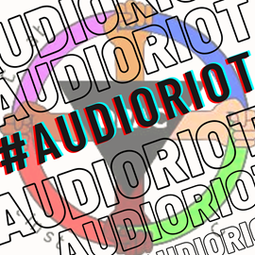
#CancelTheCut #20More4All #StopAndScrapUniversalCredit

The government increased Universal Credit by £20 per week at the start of the pandemic. They never gave it to people on legacy benefits, meaning that more than two million disabled people and carers missed out. The uplift was also temporary and ends on 30 September 2021.

Senior Tories including six former Secretaries of State for Work and Pensions have pleaded with the government not to end the cut yet. Iain Duncan Smith and Damian Green even made a last ditch attempt to get a motion to stop the cut voted on through the Pensions uprating debate but their amendment was not chosen by the speaker.

Many claimants never got the £20 uplift in the first place. It was only applied to Universal Credit so those still on legacy benefits and not yet moved over to Universal Credit were missed out. Over three quarters are disabled and their living costs have been significantly higher as a result of the pandemic and needing to shield.

The government has consistently refused to apply the uplift to legacy benefits. When questioned by Martin Lewis on the ITV Money Show, Chancellor Rishi Sunak said the uplift was meant to be for working people.

Out of work benefits in the UK are well below the amount needed for a decent standard of living. Even after the uplift, Universal Credit is just 43.4% of the minimum income standard needed for a decent standard of living. For those on legacy benefits, their social security payments all the way through the pandemic have represented just 33.9% of the minimum income standard.

All benefits need to be significantly increased, not cut.

We need people to be properly supported in these difficult times. The benefits system needs a complete overhaul. The Universal Credit system doesn’t work – it has been proven be toxic and massively harmful.

As well as fighting for a permanent uplift – we must fight for it to be scrapped and replaced with a social security system that provides a genuine safety net for all who need it.

For more information see:
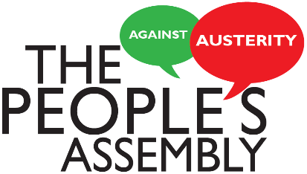
www.dpac.uk.net @dis_ppl_protest www.facebook.com/disabledpeopleagainstcuts/





